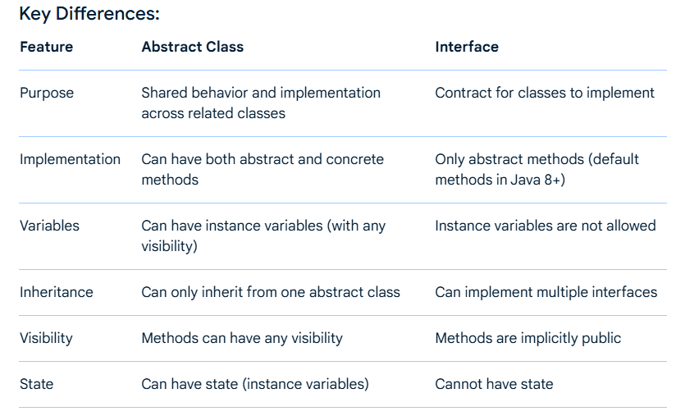

**Example:**

// Abstract class

abstract class Animal {

public void eat() {

System.out.println("Animal is eating");

}

abstract void makeSound(); // Abstract method

}

// Interface

interface Flyable {

void fly();

}

// Concrete class extending abstract class and implementing interface

class Bird extends Animal implements Flyable {

@Override

void makeSound() {

System.out.println("Bird is chirping");

}

@Override

public void fly() {

System.out.println("Bird is flying");

}

}

In this example, the Animal abstract class provides shared behavior (eat()) and an abstract method (makeSound()) that subclasses must implement. The Flyable interface defines a contract (fly()) that can be implemented by any class, including the Bird class, which extends the Animal abstract class and implements the Flyable interface.